Lab Report: Word Frequency Analyzer Using C++ STL
Title
Word Frequency Analyzer Using C++ STL

Objective
- Read text from an input file.
- Remove punctuation and convert words to lowercase.
- Ignore common stop words and short words (length ≤ 3).
- Count the frequency of each word.
- Display and save words that appear more than two times.

Introduction
This program performs basic text analysis using C++ Standard Template Library (STL). It reads a text file, cleans each word, removes common stop words, counts word frequencies using a map, and writes the results to an output file.

Libraries Used
- <iostream> – Input and output
- <fstream> – File handling
- <map> – Store word frequencies
- <set> – Store stop words
- <string> – String operations
- <cctype> – Character functions

Algorithm
- Read the input and output file names.
- Open the input file.
- Read each word from the file.
- Remove punctuation and convert to lowercase.
- Ignore stop words and words with length ≤ 3.
- Count the frequency of each remaining word using a map.
- Display and save words with frequency greater than 2.
- Close the files.

Sample Input
Data Science is interesting.
Data helps in Machine Learning.
Machine Learning is useful.
Data Machine Machine.

Sample Output
Words with frequency greater than 2:
-----------------------------------
data : 3
machine : 3

Features
- Reads text from a file.
- Removes punctuation.
- Converts words to lowercase.
- Ignores stop words.
- Counts word frequencies.
- Saves output to a file.
- Handles file opening errors.

Advantages
- Easy to understand and implement.
- Efficient use of STL containers (map and set).
- Useful for basic text analysis and preprocessing.

Limitations
- Only alphabetic characters are considered.
- Uses a limited list of stop words.
- Ignores numbers and special characters.

Conclusion
This program successfully analyzes a text file by counting the frequency of meaningful words. It demonstrates the use of C++ STL containers, file handling, and string processing, making it a simple and effective example of text analysis.

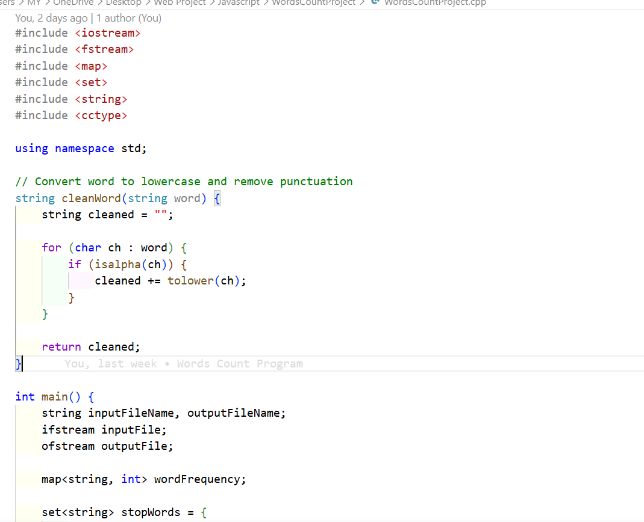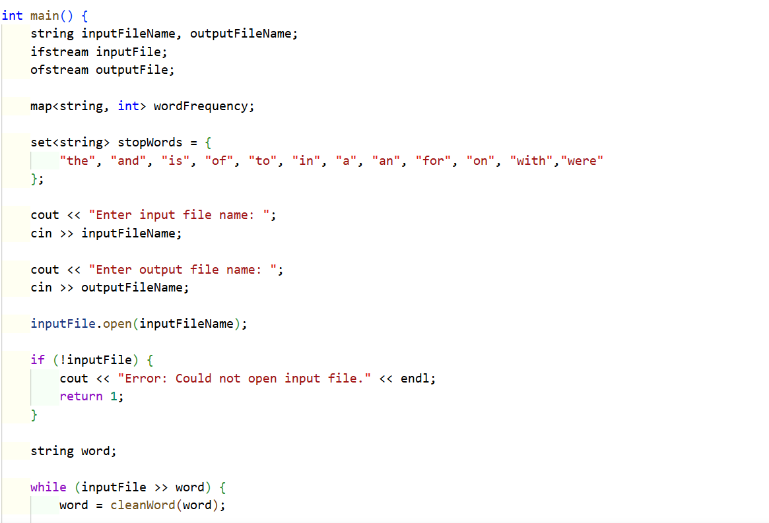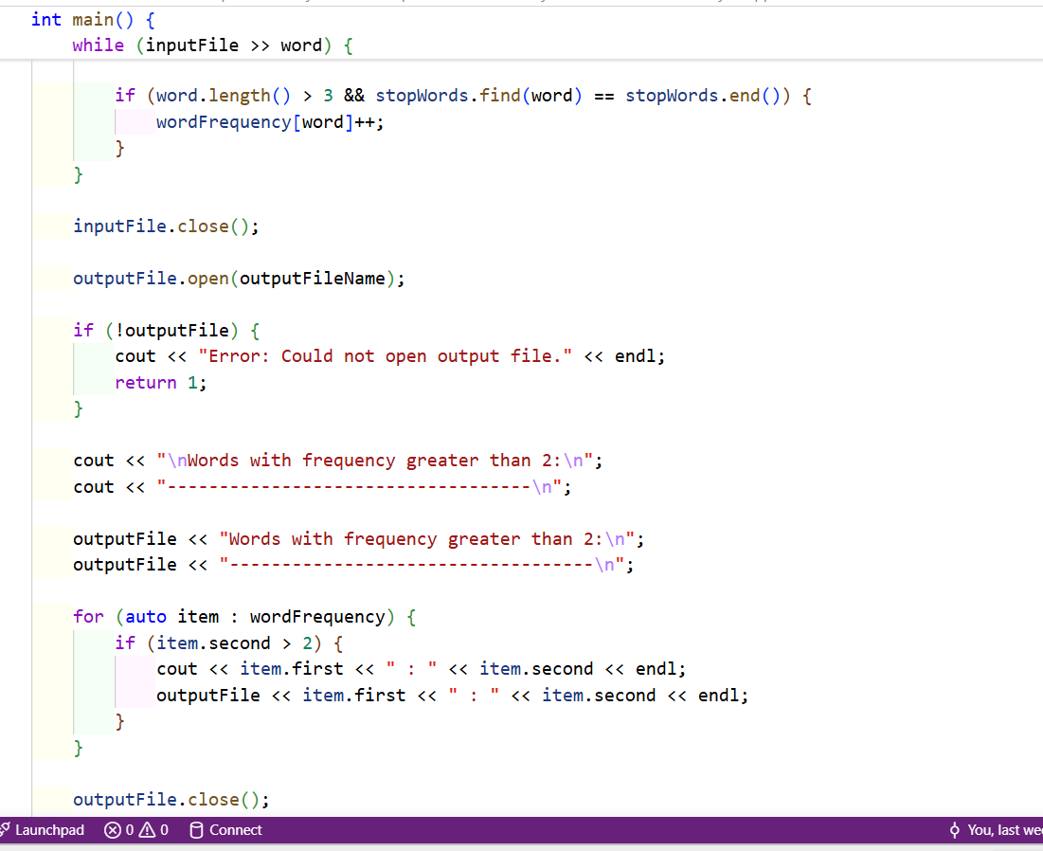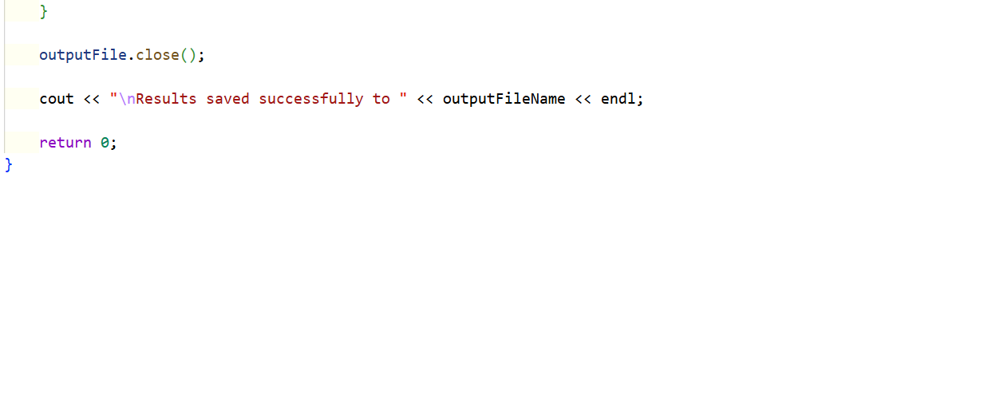
File to count Words in
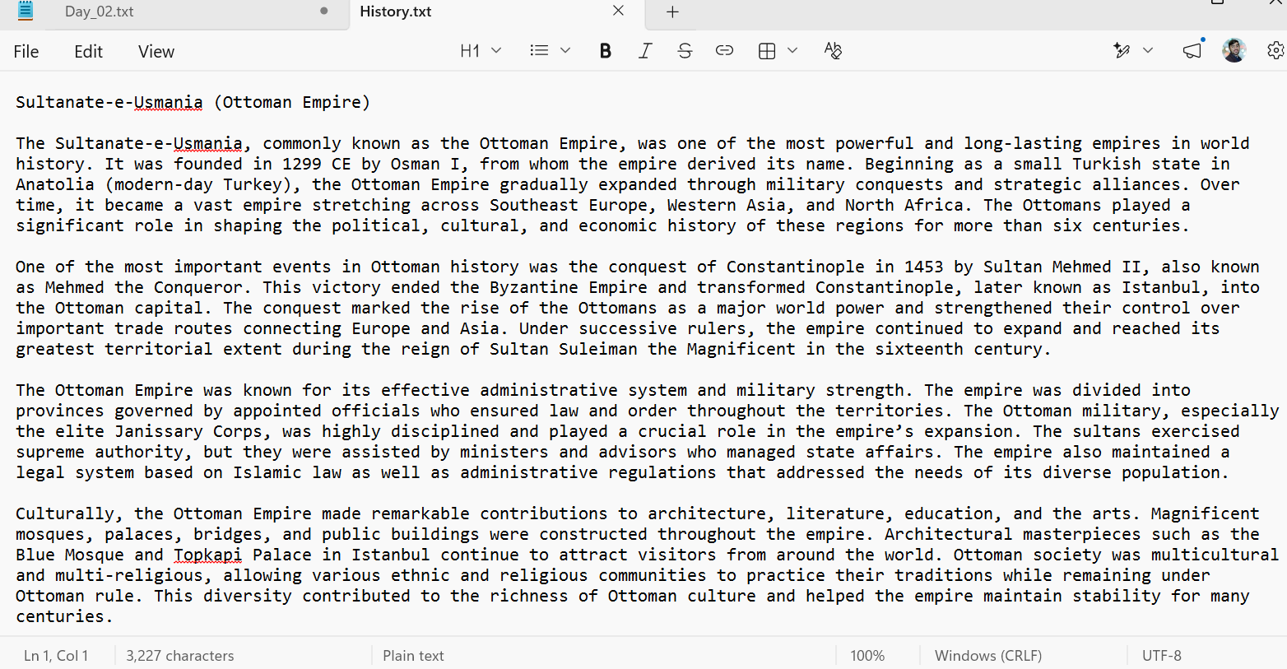

The Result:
